ESCAPISM

A game about Steven Universe trying to find Earth to contact a friend for help.

### Gameplay Overview

**Description:** You navigate through a maze path/course looking for the correct star that represents Earth. While you are moving, the screen is constantly moving up so you have to avoiding going too slow. You must defend yourself against gem enemies along the way. You can either dodge the enemies or “bubble” them***.***

**Win condition:** You find Earth

**Lose condition:** You lose three lives from getting hit by enemies, or hit the bottom of the moving screen

### Controls

**A:** Throw bubbles

**Up/Down/Left/Right:** Moves player around

**Start:** Pause game, see pause menu that allows you to return to main menu, return to game, or go to instructions

**B:** Cheat Mechanic (details below)

**Select:** Instructions

### Audio: The majority of my audio will be from Steven Universe’s musical score and episodes(if time permits…will meet the sound requirements first then add from there)

* Menu music: Spacey, ominous 8-bit music [Spaced out Beats](https://soundcloud.com/steven-universeonsc/spaced-out-beats)
* Game music: Looping Light Airy Adventurous 8-bit music [Moonlit Battlefield](https://soundcloud.com/steven-universeonsc/moonlit-battlefield)
* Pause music: Peaceful Fairy 8-bit music [Rose’s Room](https://soundcloud.com/steven-universeonsc/roses-room)
* Bubbling action (pressing A) makes a bubble [sound effect](https://freesound.org/people/ANARKYA/sounds/459568/)
* Losing (3 lives) Play 8-bit trap beat [Be Cool at the Club](https://soundcloud.com/steven-universeonsc/be-cool-at-the-club)
* Instructions music: Calm Mystic 8-bit music [Time thing](https://soundcloud.com/steven-universeonsc/time-thing)
* Winning Music: Calm Piano Music [SU Credits Song](https://soundcloud.com/steven-universeonsc/credits-theme)
* [Cheat Sound](http://reesound.org/people/harrietniamh/sounds/415083/)

### Gameplay Details

**Bubbling:** Shoots bubble sprites, Makes enemies and Stars appear to be bubbled

**Enemies:** Enemies will be located in specific parts of the game layout, if a bubble collides with them, they will be displayed within a bubble sprite and will bounce against Steven if they collide after. If an enemy collides with Steven, the player loses a life (will be displayed in top right corner)

**World Stars:** If Steven collides with a planet that is not Earth, it will show a state screen with a pic and info about that world that will prompt Steven to keep looking. If Steven throws a bubble at a star, it will be bubbled and will not have any collision effects after (process of elimination for finding Earth). **Cheat:** If the B button is held, the stars will display sprites that give a hit to what location it represents to save time on finding Earth

### Illustrations



**Figure 1:** Character movement

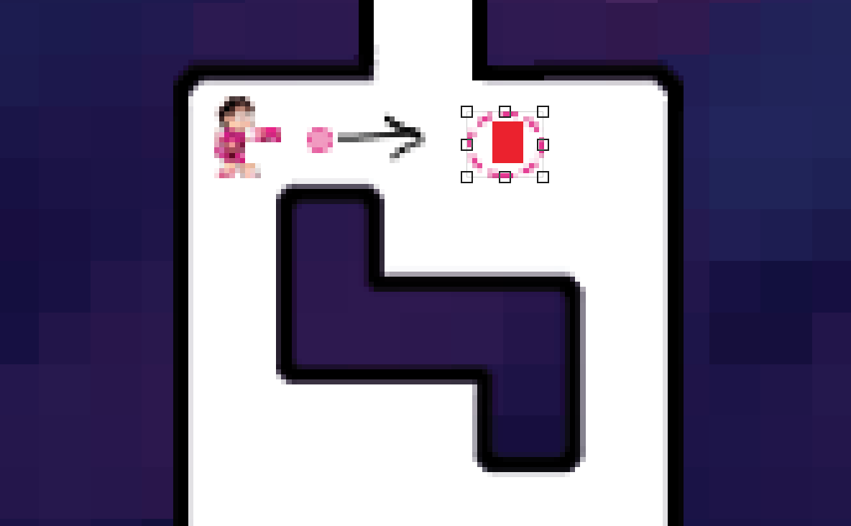

**Figure 2:** Bubbling enemies

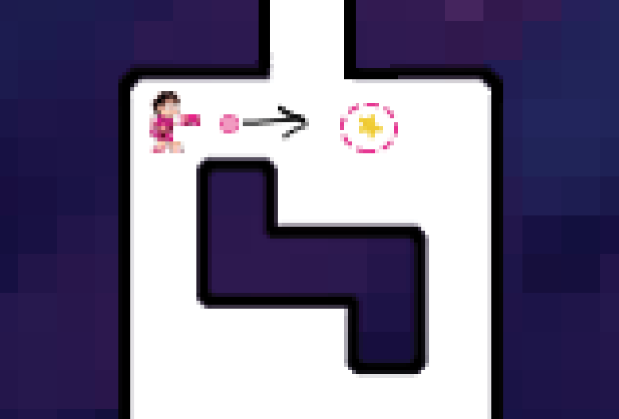

**Figure 3:** Bubbling Stars

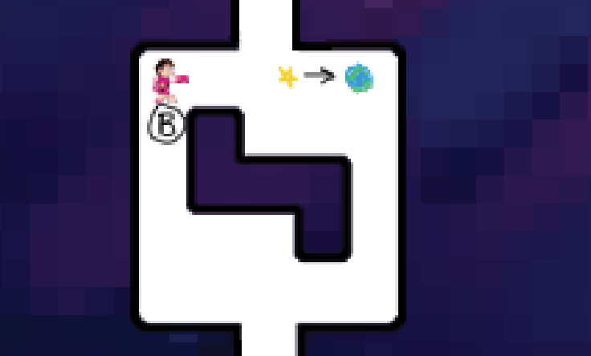

**Figure 4:** Using cheat to view location hints